Module 4 - Test driven development and Logging framework
Exercise 3: Assertions in JUnit
Code:
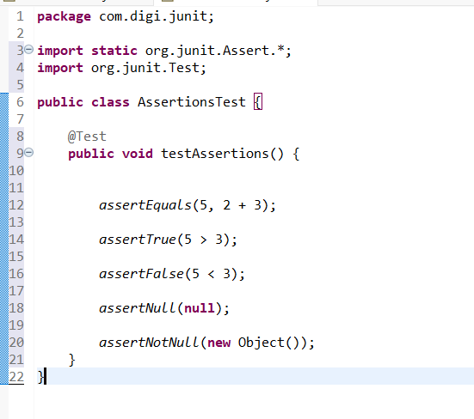

Output:
